Boston detectives recognized for work catching suspect in Mattapan armed robberies

**By Danny McDonald** Globe Staff, September 21, 2018, 6:20 p.m. **13**

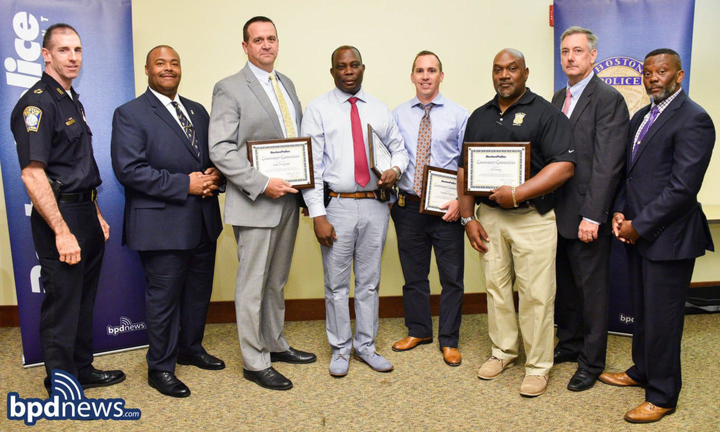

Boston police were recognized this week for helping capture an armed robbery suspect. BOSTON POLICE DEPARTMENT

Several Boston police detectives have been recognized for their work in catching a man connected to a spate of recent armed robberies in Mattapan.

Between Aug. 14 and Sept. 7, seven armed robberies took place in Mattapan, and in each of those instances, the victims were women who were walking home alone from the Mattapan MBTA station or a bus stop on Blue Hill Avenue, according to police. The robberies took place at night, between the hours of 9:45 p.m. and 2 a.m., according to police. In four of those incidents, the victims were stabbed in the lower body, police said.

Advertisement



**Vet Says: Try This If Your Dog Needs His Glands Expressed**

Sponsored by DogFoodExpose.com

Boston police detectives Juan Seoane and Matthew Fogarty canvassed the area near where the robberies occurred for video surveillance and developed a person of interest, according to police. That same person was also observed using a victim’s stolen credit card at a gas station within hours of one of the robberies.

**Get Today's Headlines in your inbox** Enter Email

[example@email.com](mailto:example@email.com)

**Sign Up**

The day's top stories delivered every morning.

The detectives captured an image of the subject and circulated that image among patrol officers. Seoane and Fogarty also found that after one of the robberies, the suspect was seen running after an MBTA bus that was leaving the area.

Police initiated a “robbery suppression plan” with units assigned to monitor specific areas, police said.

On Sept. 10, a female 16-year-old called 911 to report she had been stabbed following a robbery on Walk Hill Street. She reported she was attacked after getting off an MBTA bus, police said. Seoane and Fogarty, along with fellow Boston police detectives Al Young and Jean-Gerard Dorsainvil, and Sergeant Detective John Fitzgerald were conducting surveillance in the area and started to search for the suspect. Those detectives saw a man matching the description of the person of interest in the past armed robberies who was carrying a black backpack. The man was concealing his face under a hood, police said, and left the area on an MBTA bus.

Advertisement

The bus was stopped and the suspect, Walker Browning, was placed under arrest. Browning was found to be in possession of a small knife and was identified by the 16-year-old and past robbery victims, according to police.

Earlier this month, Browning was arraigned on armed robbery charges in connection with two separate late night robberies. He was held without bail for a probation violation at his arraignment. Since that arraignment, police have charged him in connection with five other armed robberies, the department confirmed Friday.

Seoane, Fogarty, Young, Dorsainvil, and Fitzgerald were each awarded a “commissioner’s commendation” for their efforts in catching Browning, the department announced this week.

[Danny McDonald can be reached at daniel.mcdonald@globe.com. Follow him on Twitter](mailto:DannyMcDonaldcanbereachedatdaniel.mcdonald@globe.com.FollowhimonTwitter) @Danny McDonald.

**Show 13 comments**

# BOSTON GLOBE VIDEO

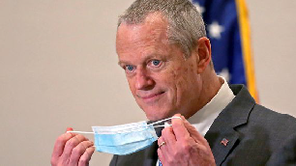

2:23

Baker announces ‘VaxMillions’ lottery program SHARE

Governor Charlie Baker announced residents who are fully vaccinated against COVID-19 will have the chance to win $1 million in a special Lottery sweepstakes. (Photo by Matt Stone/Boston Herald via AP)

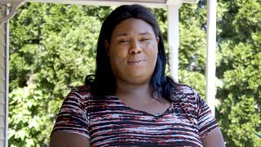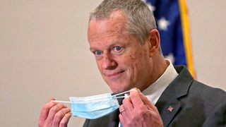

**Baker announces ‘VaxMillions’ lottery program**

**NOW PLAYING**

**Moose spotted on Route 3 in Chelmsford**

**What Black liberation means to me: Athena Vaughn**

# SEE MORE VIDEOS

**MOST POPULAR ON BOSTONGLOBE.COM**

1. Some lawmakers want to ban critical race theory in schools. So, what is it?
2. ‘Matty in the Morning’ co-host Rebekah ‘Bex’ Maroun is leaving Kiss 108 following on-air incident
3. Life sciences is poised to be Boston’s dominant industry. Has the area become the Silicon Valley of biotech?
4. Is there something wrong with the air in South Portland, Maine?
5. The state’s second-biggest health insurer has a buzzy new name
6. I got the Johnson & Johnson vaccine. The pause makes me believe in it more.
7. ‘My Name Is Bulger’: A tale of two brothers
8. Baker announces ‘VaxMillions’ lottery program, offering $1 million cash prizes to boost vaccination rates
9. Coolidge Corner Theatre unveils plans for major expansion
10. A treasure map for an American tyrant



**VIEWS FROM OUR COLUMNISTS**

**YVONNE ABRAHAM**

Energy efficiency is a low-hanging fruit to combat climate change. So why can’t everyone get access to it?

**KEVIN CULLEN**

Bill Bratton on American policing and the challenge facing the Boston Police Department

**THOMAS FARRAGHER**

A salute across the ages to an old squad leader

**SHIRLEY LEUNG**

A working mother’s manifesto: Pandemic provides a once-in-a-generation chance to course correct how we work

**JENEÉ OSTERHELDT**

The pride I carry with me: Karim

**ADRIAN WALKER**

‘The best Boston movie no one’s ever seen’: ‘Blue Hill Avenue’ at 20

**MORE ON GLOBE.COM**

**PROVIDED BY: PEABODY ESSEX MUSEUM**

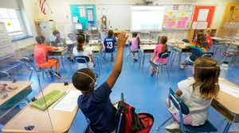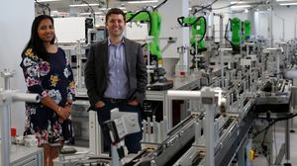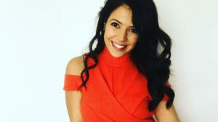

**The exhibit that’s painting a broader picture of seascapes**

This summer, visitors to the Peabody Essex Museum will see that marine painting is so much more than ship portraits.

**THE GREAT DIVIDE**

**Some lawmakers want to ban critical race theory in schools. So, what is it?**

As national debate over race-related curriculums rages on, here is a lesson on the subject and the controversy surrounding it.

**INNOVATION ECONOMY**

**Life sciences is poised to be Boston’s dominant industry. Has the area become the Silicon Valley of biotech?**

Since December, you can find six major indications that Boston is the undisputed center of the life sciences industry, a place where ideas and products that change — and save — people’s lives around the world originate.

**‘Matty in the Morning’ co- host Rebekah ‘Bex’ Maroun is leaving Kiss 108 following on-air incident**

Co-host/executive producer Rebekah “Bex” Maroun announced on Wednesday that she would be leaving Kiss 108 to move home to her native Philadelphia. Her departure caps a turbulent month for “Matty in the Morning,” the drive-time show helmed by long-time host Matt Siegel.

**The state’s second-biggest health insurer has a buzzy new name**

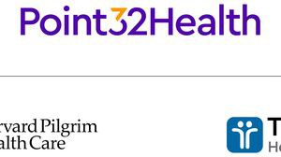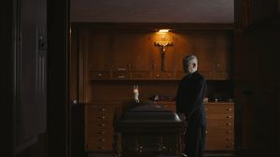

Tufts Health Plan and Harvard Pilgrim Health Care merged in January but didn't name the new company they created until Wednesday: Point32Health.

**‘My Name Is Bulger’: A tale of two brothers**

The Discovery+ film offers an unusually intimate view of Whitey and Bill Bulger.

**GLOBE MAGAZINE**

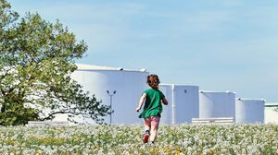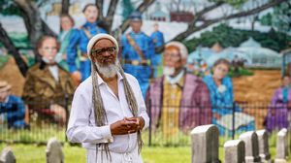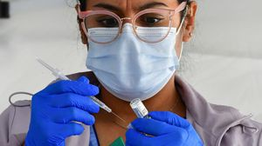

**Is there something wrong with the air in South Portland, Maine?**

Residents have lived near more than 100 massive petroleum storage tanks for decades, never really knowing if they’re breathing in dangerous chemicals. Now they’re fighting to find out.

**How Massachusetts communities are celebrating the state’s first official Juneteenth**

For more than a century, Juneteenth was a Texan holiday, then a Southern holiday, commemorating the anniversary of June 19, 1865, when General Gordon Granger of the Union Army told formerly enslaved people in Galveston they were free. Now it will be celebrated for the first time across the Commonwealth as an official state holiday.

**OPINION**

**I got the Johnson & Johnson vaccine. The pause makes me believe in it more.**

The worst thing that could happen now is for the recommendation by the FDA and CDC to pause the vaccine’s administration to spur a new wave of vaccine hesitancy.

**The case for prosecuting Donald Trump**

Saving American democracy for the long run requires a clear condemnation of the Trump presidency. That means making clear that no one is above the law.

**MOST READ IN THIS SECTION**

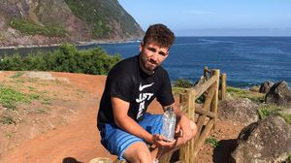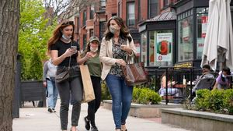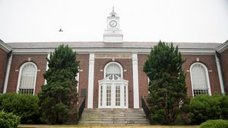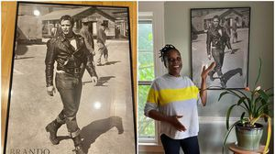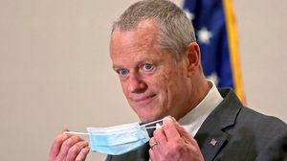

**THE GREAT DIVIDE**

**Some lawmakers want to ban critical race theory in schools. So, what is it?**

**RI NEWS**

**Message in a bottle, tossed into the sea in Rhode Island, found in Azores**

**GLOBE MAGAZINE**

**Is there something wrong with the air in South Portland, Maine?**

**The downside of ditching masks: the return of colds, flu**

**UMass Lowell to remain closed Wednesday while investigating ‘cybersecurity incident’**

**The strange tale of Arlington’s mysterious Marlon Brando poster**

**How Massachusetts communities are celebrating the state’s first official Juneteenth**

**Baker signs bill extending pandemic-era policies, including to-go cocktails, expanded outdoor dining**

**FOLLOW US**

**SUBSCRIBE NOW MY ACCOUNT CONTACT MORE**

Digital Access / Home Delivery / Gift Subscriptions

Log In /

Manage My Account / Customer Service

Help & FAQs / Globe Newsroom / Advertise

Newsletters / View The EPaper /

Order Back Issues / News In Education / Search The Archives / Privacy Policy / Terms Of Service / Terms Of Purchase / Work At Boston Globe Media /

Do Not Sell My Personal Information

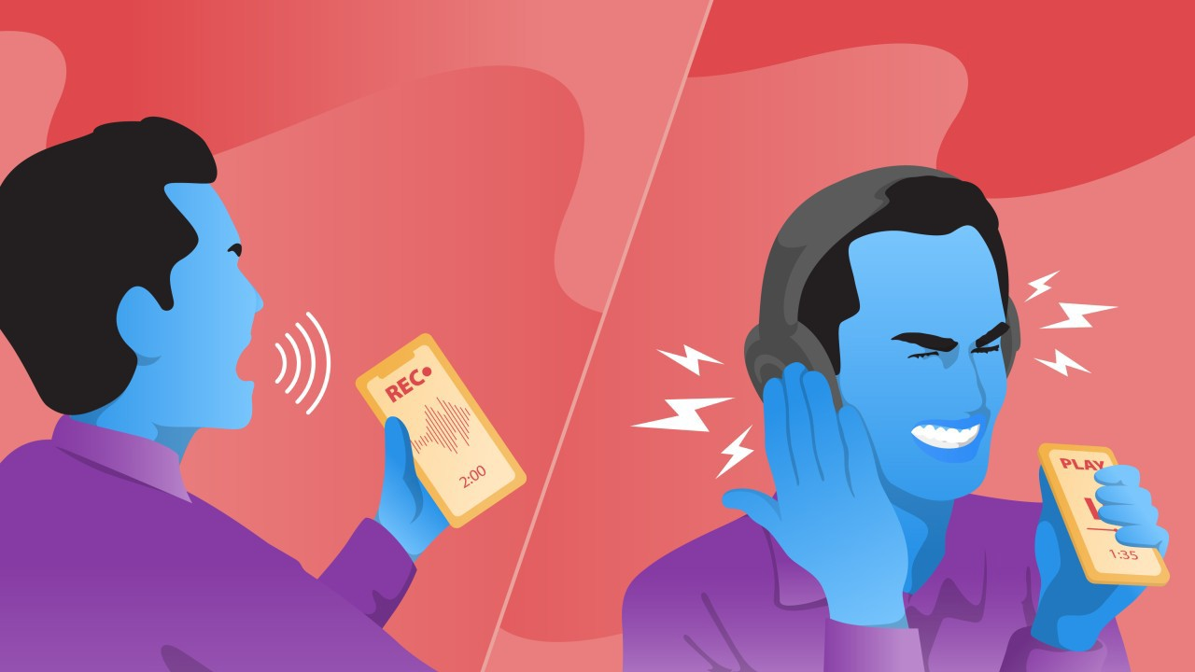

**Same-Day Transcription**

Rev.com

**Learn more**

**METRO SPORTS BUSINESS & TECH OPINION**

WELCOME, JOHN

**TODAY'S PAPER**

**Summer Fitness Challenge Starts Monday**

Sign up now

©2021 Boston Globe Media Partners, LLC